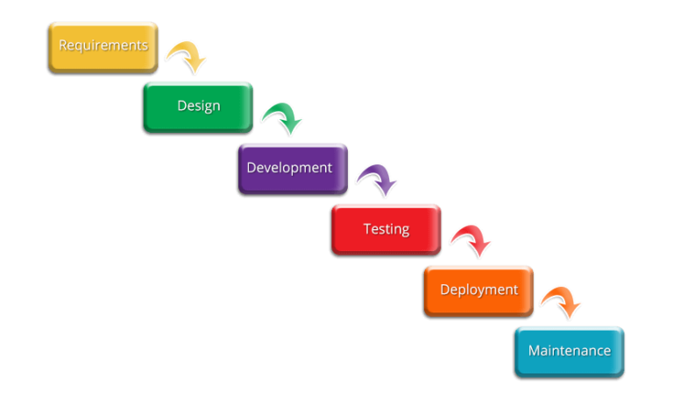**Waterfall Project Management**

**Example from:** https://www.itonlinelearning.com/blog/effective-project-management-methodologies/?utm_feeditemid=&utm_device=c&utm_term=&utm_source=google&utm_medium=ppc&utm_campaign=Become+a+Project+Manager+DYNAMIC&hsa_cam=17620632692&hsa_grp=139883157482&hsa_mt=&hsa_src=g&hsa_ad=607057236870&hsa_acc=1636904472&hsa_net=adwords&hsa_kw=&hsa_tgt=dsa-933566488239&hsa_ver=3&gclid=EAIaIQobChMInPO2stbG-wIVx-vtCh1pSg5JEAAYASAAEgKjVPD_BwE

I will be using a waterfall type of project management as this seems to be the most suited to what I am doing. This is because my project has a predetermined goal which won’t change so I can make a step-by-step plan where everything must be done in a predetermined sequence. Waterfall project management use a sequence of tasks which must be completed before the next task can begin, this is especially suited to me as for example I will not be able to complete my website without completing my research as I will have no knowledge on what tools I must implement.

I have already began to implement this by creating a Gannt chart which ensures I follow a step by step plan.